**CS5250 Advanced Operating Systems**

**Pop Quiz 4**

**(Due: 16 Feb 2021, 11pm)**

Name: ______Daniel Alfred Widjaja_____________________________

Student Number: __A0184588J______________________

This is a small programming exercise on Linux signals.

Write a simple C program that satisfy the following specifications:

1. The main body performs an infinite loop.
2. Using the signal mechanism, when it receives a CTRL-C from the keyboard, the program will merely print out “Sorry, I’m staying… not going anywhere.” and continues with the infinite loop.
3. When it receives the signal 10, it will print out “Alright, since you really want me dead. Goodbye, cruel world!” and exits.

Show (by screen capture) how you it behaves. Hint: you may need two windows so that you can send the termination signal to the infinite loop program.

Submit your answer in a PDF into the corresponding Luminus submission folder.

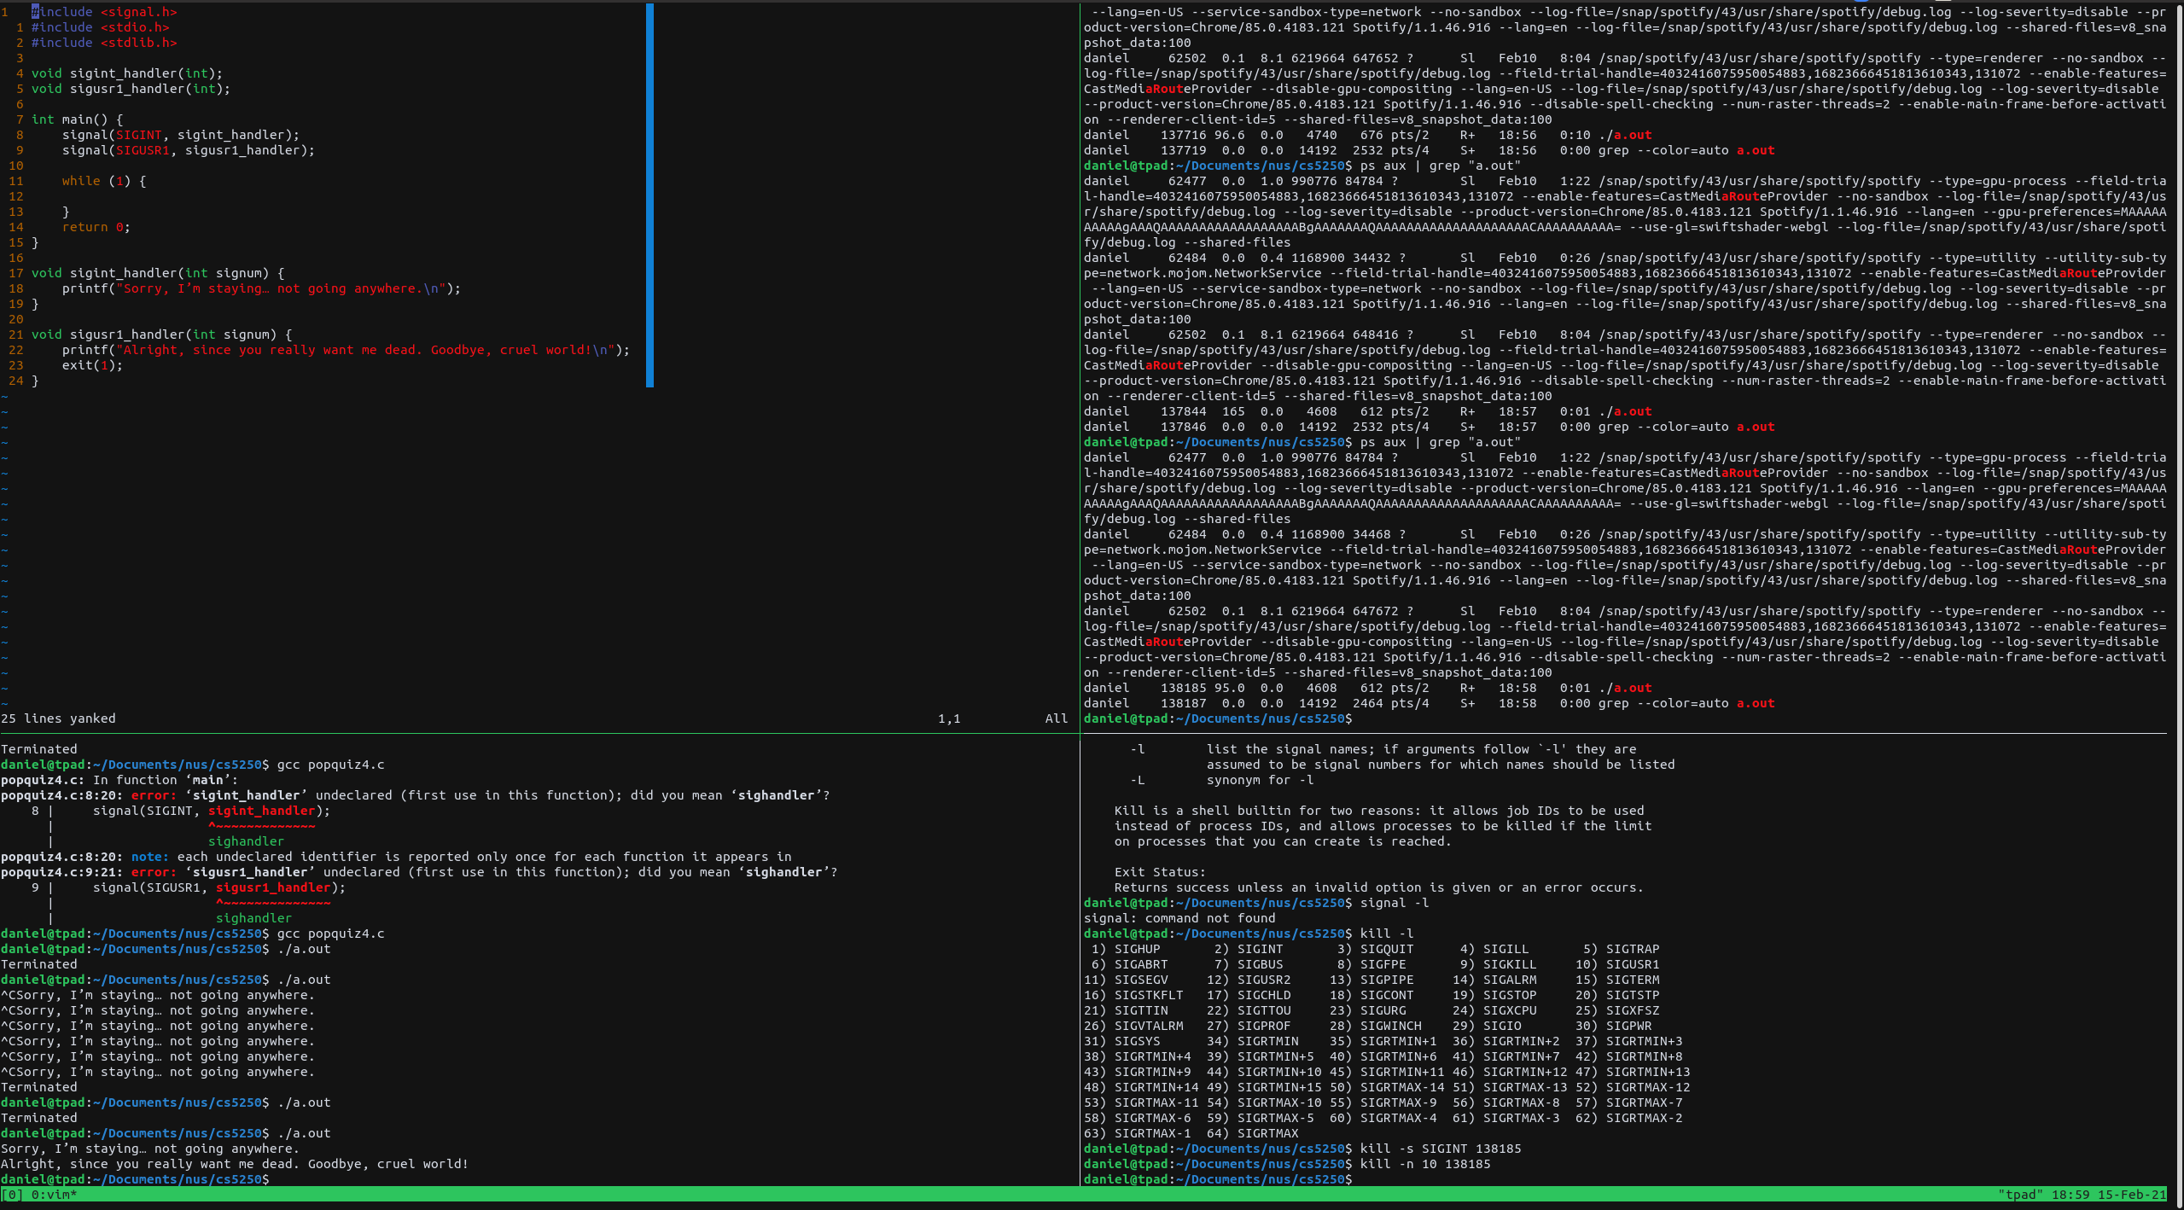

#include <signal.h>

#include <stdio.h>

#include <stdlib.h>

void sigint_handler(int);

void sigusr1_handler(int);

int main() {

signal(SIGINT, sigint_handler);

signal(SIGUSR1, sigusr1_handler);

while (1) {

}

return 0;

}

void sigint_handler(int signum) {

printf("Sorry, I’m staying… not going anywhere.\n");

}

void sigusr1_handler(int signum) {

printf("Alright, since you really want me dead. Goodbye, cruel world!\n");

exit(1);

}